Greenhouse Project

Designing a computer network

**Problem 1:**

1. Gather all the necessary information about your home network, including the types of devices (for example smartphone, laptop, smart TV, et cetera) connected to it, the router, and any other networking equipment (for example Wi-Fi access points, switches, et cetera).
2. Create a network diagram using a tool such as draw.io or Packet Tracer.
3. Label each device, give the IP address for each device in the network, and indicate its connection to other devices.
4. Include a legend or key in the diagram to explain the different symbols and colors used to represent different types of devices.
5. Once the diagram is complete, take a screenshot or export it as an image file and submit it along with a brief written explanation of your home network and any challenges or issues you encountered while creating the diagram.

**Action:**

* Home network diagram

I used draw.io to make this network diagram. Here the internet we have access to first goes through a firewall and then goes the router to which all the devices I have are connected to.

**Feedback:** I was told I had swapped the line symbols for ethernet and glasfiber, so I fixed that.

**Reflection:** I had trouble with creating the right order in which the items in the diagram had to be displayed. After doing a google search I learned the right arrangement of the elements.

**Decision:** My goal is to learn about better security.

**Problem 2:** A company has been experiencing frequent network crashes and slow performance, causing difficulties for employees and loss of sales.

1. Create a visual representation of the current network design.
2. Include any additional devices or elements that you believe are necessary for a functional network. Once your diagram is complete, you must write a short summary describing the current design and explaining the issues it presents.

**Action:**

The company’s current network includes only a router, which connects all the devices in the store, including the cash registers, security cameras, and employees’ computers. Additionally, there is a wireless network for employees and a wireless network for customers.

Current network:

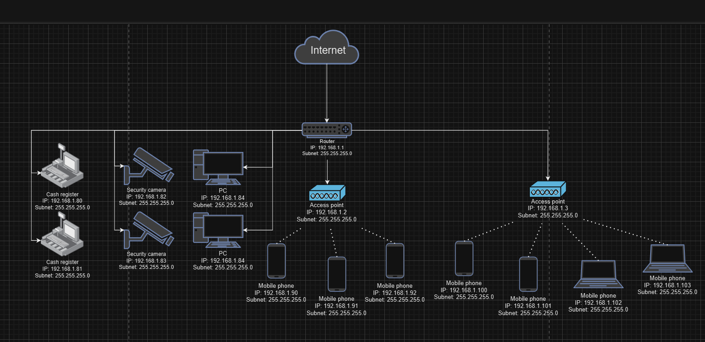

Issue 1: All devices are connected to a single router, causing crashes

Issue 2: Single wireless network shared between guests and employees causes crashes and slow performance

Issue 3: No firewall, causing security risks

Issue 4: No separation between customer, employee, and business traffic, causing security risks.

Updated network:

I added a firewall, a main switch to which every network’s router is connected to, and a switch in every network to which the devices are connected to. I believe this diagram is more efficient and secure than the first one.

Reflection: After completing the infrastructure assignments, this one seemed easier to solve.

Decision: My goal is to keep learning more about networks.